**Course: Advance Bio Informatics**

**Module Title: Distance Matrix for Phylogenetic analysis**

**Module No: 66**

**Distance Matrix**

Construct multiple alignments of sequences

Construct table listing all pairwise differences (distance matrix)

Construct tree from pairwise distances

**Example**

Gorrila: ACGTCGTA

Human: ACGTTCCT

Chimp: ACGTTTCG

**Human Gorilla Chimp**

Human - 4 2

Gorilla - 4

Chimp -

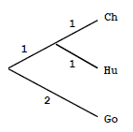

Consult ppt presentation and video lectures for details of this lecture.